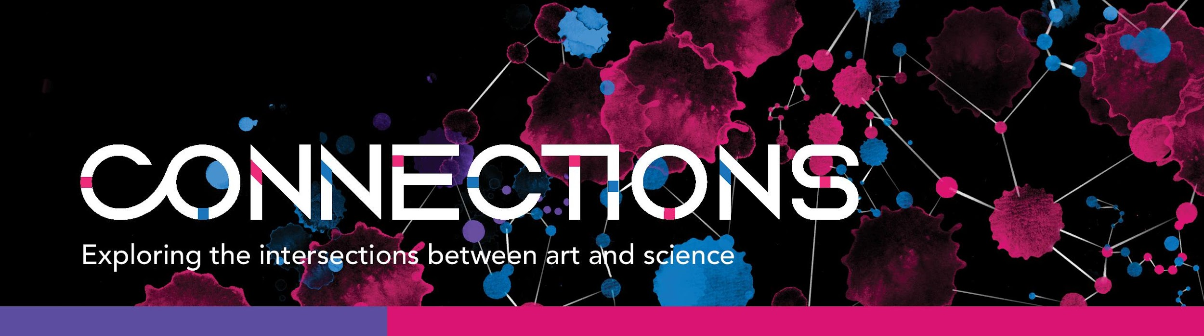
Call for Submissions - Deadline extended
The Neuroscience and Mental Health Institute (NMHI) is launching the “CONNECTIONS” project: a collection of artwork and scientific images that portrays the many aspects of neuroscience, brain diseases and mental health, and where art and neuroscience meet. The NMHI invites artists, scientists and persons with relevant lived experience to submit artwork that relates to this theme.
Connections among brain cells make our brain work and determine who we are and how we feel and interact with the world. Connections within the brain and with the world around us can be lost or compromised in many brain diseases and mental health conditions. And, sometimes, they can be restored through empathy and care. From the neuroscientist to the patient, the carer and the clinician, NMHI believes that true and meaningful progress means everyone working together to understand, share, and empathize in order to promote connections, advance science, support each other and improve the life of those with neurological and mental health conditions.
The Connections project is an opportunity to showcase the connection between art and neuroscience as well as to support research at the NMHI. The NMHI at the University of Alberta is a multi-disciplinary research and teaching institute at the University of Alberta. It is home to over 150 scientists and clinicians dedicated to discovering how the nervous system works and the causes of neurological and mental health disorders, to develop new treatments and advance clinical care.
PROJECT STAGES
Artists may submit paintings, photographs, compelling neuroscience images, poetry, sculptures, multi-media artwork and other forms of expression that are in line with the “CONNECTIONS” theme. Selected artwork and images will be curated for the “CONNECTIONS” project, which will be rolled out in stages:
Stage I: online gallery hosted on the NMHI website (Fall 2021/Winter 2022);
Stage II: special edition eBook (Winter 2022) available for online purchase and printing;
Stage III: live exhibition, limited edition set of prints and fundraising event to support research at the NMHI (Summer/Fall 2022, pandemic and other conditions allowing).

Stage I and II will showcase artists and their artwork through an online platform. Artwork showcased at the exhibition/fundraising events (Stage III) and the limited edition set of prints will be offered for sale at a silent auction (upon agreement with the contributors) to raise funds to support research at the NMHI. For each original artwork sold, the contributor/artist will receive an amount agreed upon ahead of time by the artist and the CONNECTIONS organizing and art curation committee.

Artwork and images selected as part of the “CONNECTIONS” project (Stage II) will participate in a Popular Choice Contest, with online voting and the following prizes: 1st place, $500; 2nd place, $250; 3rd place, $100.

HOW TO SUBMIT
Please complete and sign the attached form and agreement and email it to nmhicoms@ualberta.ca along with photos of your artwork submission(s). All images should be saved as jpegs or TIFFs, RGB, at least 9 x 12 inches, at least 300 dpi. Please include your last name in the file name. Please also send a brief statement explaining your work and what inspired you to participate (no more than 500 characters) and a short biography (no more than 350 characters). The deadline for submissions is October 17th, 2021. The Authors of artwork selected for the CONNECTIONS project will be notified by the end of November 2021.

Submission Form

Artist/Contributor Name (required):
Email (required):
Other Contact Information:
Artwork Title (required):
Artwork Type and Media Used (required):
Short Biography (max 350 characters)

Artwork Description and Source of Inspiration (max 500 characters)

Agreement with artists and contributors
The goal of CONNECTIONS is to increase awareness about neuroscience and mental health and raise funds to support related research at the Neuroscience and Mental Health Institute.

Stage I and Stage II
Artwork submitted and selected for the CONNECTIONS collection will be part of a virtual online gallery hosted on the NMHI website, and an eBook available for printing and purchase on the NMHI and CONNECTIONS website.
1. Artists and collaborators understand that:
- All submitted artwork will undergo a selection process by the NMHI and the CONNECTION organizing committee. Not all submitted artwork will be selected to become part of the CONNECTIONS project.
- Copyright in submitted artwork is retained by the artist/creator. The artist/creator grants to NMHI a non-exclusive, royalty-free license to reproduce and distribute copies of the artwork as described herein. All uses of submitted artwork under this agreement will include attribution to the artist/creator.
- Given that one of the goals of this project is to raise funds to support research in neuroscience and mental health, all proceeds arising from the CONNECTIONS project, including from sales of the eBook, the limited edition set of prints or any related donations, will go to the NMHI.
2. Artists and collaborators agree to:
- Have a copy of their artwork, along with their name and brief biosketch (may be edited for brevity and clarity), published on the CONNECTIONS website and, if selected for inclusion, published in ebook and printed version of the book and/or limited edition set of prints. Note that there is the option to be cited as “Anonymous”.
- Have their artwork reproduced for use in publicity for future NMHI non-profit related initiatives and/or educational purposes. Any such use of the artwork will include attribution to the artist/creator.

Artist/Collaborator Name:
Address:
Email: Phone:
Signature: Date:

Stage III
Selected artwork may become part of a curated live exhibition at the University Hospital McMullen Gallery (Summer/Fall 2022), a fundraising virtual auction, and a limited series prints edition offered for sale to support research in neuroscience and mental health at the NMHI.

Please read the sections below that outline the terms and conditions of participation in Stage III, and indicate your choice concerning your willingness to have your artwork considered for Stage III of the project.

1. Artists and collaborators agree to:
1.1 All the conditions listed for Stage I and II.
1.2 Make the originals of their artwork physically available for the live exhibition.
1.3 Waive any fee for the inclusion of their work in the live exhibition.
1.4 Make any artwork available for sale at the live exhibition, subject to an agreement in advance with the CONNECTIONS organizing and art curation committee regarding the amount that will go to the artist in the event of such a sale. It is understood that a significant portion of the proceeds of any such sale will go to the NMHI to support research in neuroscience and mental health.
2. Artists and collaborators understand that: If the artwork is not sold at the end of the exhibition, the artwork will be returned to the artist.
3. Please check all that apply:
I wish my artwork to be considered for inclusion in the live exhibition in Stage III YES NO
I understand and accept the conditions for participating to the live exhibition YES NO
I consent to my work to be offered for sale according to the conditions indicated under 1.4 YES NO

Signature: Date:

