simplified loan agreement 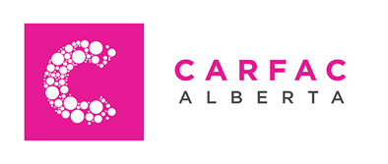
CARFAC Alberta requests the loan of the following objects from:
Lender (Artist):
Address:

Postal Code:

Email:

City, Province:
Phone:
For the purpose of: Perspectives from Within: September 2020 –
Description of Work:
Title Media Size Value
1_____________________________________________________________________________________________________________
2_____________________________________________________________________________________________________________
3_____________________________________________________________________________________________________________

I I authorize CARFAC Alberta to conduct the sale of my work. I understand that a 10% administration fee will be charged on all sales.
I prefer to handle all sales privately. I authorize CARFAC Alberta to distribute my contact information to potential clients.
The work is NOT for sale
CARFAC Alberta gratefully acknowledges the receipt of the artwork(s) listed above. We agree to insure the artworks against damage or loss for the value set by the artist and recorded above. CARFAC Alberta does not accept liability beyond this amount or beyond 90 days from close of the exhibition. It is the sole responsibility of the artist to transport the artwork(s) to the CARFAC Alberta Project Space
(3rd Floor, 10215 – 112 Street, Edmonton, AB T5K 1M7) on or before___________________. If using an economical courier (e.g. Greyhound), CARFAC Alberta will pay for the return shipment. If you choose to drop off and pick up your work from the Project Space, a cheque for $100 will be issued. For Packing instructions: please read the attached letter: Contract & Exhibition/Transportation details”. Artworks received not following these guidelines will not be insured if damaged in transit. Damages occurring during transit shall be reported to the carrier immediately.
Unless otherwise stated herein by the artist, it is understood that the artwork(s) named on this form may be photographed for records, publicity, or educational uses only. For participating in Perspectives From Within, each artist will receive a $_______ artist fee.
Drop off date Pick up date
Lender

CARFAC Alberta Representative

