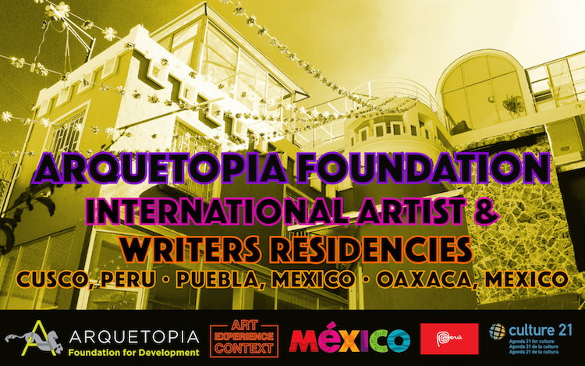

Arquetopia Foundation
Puebla, Mexico – Oaxaca, Mexico – Cusco, Peru
Self-Directed & Instructional Artist & Writers Residencies:
All Sessions in 2018

Fee Reduction Possible: Apply Now Through Sunday, May 27, 2018.
Spaces are limited. All residency applications are evaluated for selection when they are received vs. after the deadline has passed.

Website: http://www.arquetopia.org/new-open-calls-deadlines
E-mail Chris at info@arquetopia.org for more information.

Founded in 2009, Arquetopia Foundation is an internationally established, award-winning nonprofit arts and cultural foundation with a social scope that emphasizes critical thinking through artistic practices. Our academic International Artist-in-Residence Programs are the largest and most reputable in Latin America, with an array of contents anchored in a solid structure of collaborations with prominent cultural institutions, renowned experts, and notable artists. We are invested in approaching art and art history with a critical perspective by understanding Mexico and Peru’s complexity in context and incorporating nuances in narratives and interpretation especially of the 3,000-year heritage of visual culture of these two countries. Our residency programs offer competitive professional opportunities for emerging and mid-career, national and international artists, designers, curators, art historians, art educators, writers, journalists, and cultural researchers age 22 and over.

We are currently welcoming applications for the following residency programs in Puebla, Mexico; Oaxaca, Mexico; and in Cusco, Peru:

SELF-DIRECTED RESIDENCIES FOR ARTISTS, ART HISTORIANS, WRITERS, & RESEARCHERS: ALL SESSIONS IN 2018
Program fee indicated is per week, in US Dollars.
Click on each link below for program info on our website.

1. Short-Term Artist Residencies: Mapping Narratives or Exploring Authority.
Puebla, Mexico; Oaxaca, Mexico; or Cusco, Peru
http://www.arquetopia.org/our-artist-residencies/short-term-artist-residencies
Self-directed, tour-inclusive sessions of 2 weeks in the majestic central historic district of Puebla; in the Oaxaca countryside; or in Cusco’s Sacred Valley of the Incas. Various techniques and resources offered. 549/649/749

2. Art, Design, or Photography Production Residency.
Puebla, Mexico or Cusco, Peru
http://www.arquetopia.org/our-artist-residencies/self-directed/art-design-or-photography-residency
Self-directed sessions of 4 to 12 weeks in the majestic central historic district of Puebla; or 3 to 12 weeks in Cusco’s Sacred Valley of the Incas. Various techniques and resources offered. 495/595

3. Mexican Ceramics Residency.
Puebla, Mexico
http://www.arquetopia.org/our-artist-residencies/self-directed/mexican-ceramics-residency
Self-directed sessions of 6 to 12 weeks in the majestic central historic district of Puebla. 595

4. Printmaking Residency.
Puebla, Mexico
http://www.arquetopia.org/our-artist-residencies/self-directed/printmaking-residency
Self-directed sessions of 4 to 12 weeks in the majestic central historic district of Puebla. 595

5. Art Educators Residency.
Puebla, Mexico
http://www.arquetopia.org/our-artist-residencies/self-directed/art-educators-residency
Develop new art education projects with students, exploring diverse pedagogic techniques with multiculturalism. Self-directed (staff-assisted) sessions of 4 weeks in the majestic central historic district of Puebla. 645

6. Art History or Cultural Research Residency.
Puebla, Mexico
http://www.arquetopia.org/our-artist-residencies/art-history-or-cultural-research-residency
Explore magnificent southern Mexico’s unique archives and resources from pre-Hispanic to contemporary. Self-directed (staff-assisted) sessions of 3 to 8 weeks in the majestic central historic district of Puebla. 529

7. Showcase Art Exhibition Residency.
Puebla, Mexico
http://www.arquetopia.org/our-artist-residencies/self-directed/showcase-art-exhibition-residency
Self-directed (staff-assisted) sessions of 5 weeks in Puebla, culminating in an art exhibition at Arquetopia’s new Decentered Gallery in the majestic central historic district. 759

8. Writers Residency.
Oaxaca, Mexico or Cusco, Peru
http://www.arquetopia.org/our-artist-residencies/writers-residency
Self-directed sessions of 3 to 8 weeks in the beautiful countryside of Oaxaca or Cusco’s Sacred Valley of the Incas. 529/549

ARTIST RESIDENCIES WITH MASTER TECHNIQUE INSTRUCTION: ALL SESSIONS IN 2018
Program fee indicated is per week, in US Dollars.
Click on each link below for program info on our website.

9. Mexican Textiles Instructional Residency: Weaving, Embroidery, or Tapestry.
Oaxaca, Mexico
http://www.arquetopia.org/our-artist-residencies/instructional/mexican-textiles-residencies
With master instruction, learn traditional Mexican Textiles (back-strap Weaving, Embroidery, or Tapestry) in the countryside of Oaxaca, with time for independent production. Extendable sessions of 3 or 4 weeks. 729

10. Peruvian Textiles Instructional Residency: Andean Weaving.
Cusco, Peru
http://www.arquetopia.org/our-artist-residencies/instructional/peruvian-textiles-residency
With master instruction, learn traditional Andean Weaving in Cusco’s Sacred Valley of the Incas, with time for independent production. Extendable sessions of 3 weeks. 749

11. Natural Ink Silkscreen Instructional Residency.
Oaxaca, Mexico
http://www.arquetopia.org/our-artist-residencies/instructional/natural-ink-silkscreen-residency
With master instruction, learn Natural Ink Silkscreening techniques and pigments in the beautiful countryside of Oaxaca, with time for independent production. Extendable sessions of 3 weeks. 729

12. Natural Pigments Instructional Residency.
Oaxaca, Mexico or Cusco, Peru
http://www.arquetopia.org/our-artist-residencies/instructional/natural-pigments-residency
With master instruction, learn to create and use a variety of Natural Pigments in the beautiful countryside of Oaxaca or in Cusco’s Sacred Valley of the Incas, with time for independent production. Extendable sessions of 3 weeks. 749

13. Gold Leafing and Estofado Instructional Residency.
Puebla, Mexico or Cusco, Peru
http://www.arquetopia.org/our-artist-residencies/instructional/gold-leafing-residency
With master instruction, learn Gold Leafing (Gilding) and Estofado techniques in the majestic central historic district of Puebla or in Cusco’s Sacred Valley of the Incas, with time for independent production. Extendable sessions of 3 weeks. 665

14. Organic Painting Instructional Residency.
Puebla, Mexico
http://www.arquetopia.org/our-artist residencies/instructional/novohispanic-arts-residencies
With master instruction, learn Organic Painting techniques in the majestic central historic district of Puebla, with time for independent production. Extendable sessions of 3 weeks. 665

15. Peruvian Arts Instructional Residency: Painting or Sculpture.
Cusco, Peru
http://www.arquetopia.org/our-artist-residencies/instructional/peruvian-arts-residencies
With master instruction, learn one of two Peruvian art techniques: Painting or Sculpture, in Cusco’s Sacred Valley of the Incas, with time for independent production. Extendable sessions of 3 weeks. 749

16. Pre-Columbian Ceramics Instructional Residency.
Puebla, Mexico
http://www.arquetopia.org/our-artist residencies/instructional/novohispanic-arts-residencies
With master instruction, learn pre-Columbian Ceramics techniques in the majestic central historic district of Puebla, with time for independent production. Extendable sessions of 5 weeks. 637

HOW TO APPLY
Visit the Arquetopia website at www.arquetopia.org
E-mail Chris at info@arquetopia.org for complete information dossier.
Complete and submit the Arquetopia Artist-in-Residence Online Application Form, following the instructions on the web page.
Following selection, applicants are notified immediately via e-mail.

Arquetopia is distinguished worldwide for its array of unique residency programs with substantial content. In contrast to various property rental schemes, tourist resorts, B&B’s, and sublets elsewhere, our residency spaces function exclusively for productive art professionals, writers, and researchers and are built on structured, informative programs; a network of collaborative workspaces, institutions, and studios; and individualized project support.

Arquetopia is committed to providing an inclusive and welcoming environment for all members of our diverse local and international community. Arquetopia’s resident artist and staff backgrounds vary in all aspects. As part of Arquetopia’s mission is to promote diversity, Arquetopia actively fights discrimination by offering access to its programs and activities without regard to race, color, gender or gender expression, national origin, age, religion, creed, or sexual orientation.

